Plant Classification (S5L1b)

Study Guide

**Vocabulary:**

vascular- plant that has tube-like water transport system

nonvascular- plant that does not have tube-like transport system

angiosperm- vascular plant that produces seeds from flowers

gymnosperm- vascular plant that produces seeds from cones

spore- small reproductive structures usually made of one cell

|  |  |  |  |  |
| --- | --- | --- | --- | --- |
| Plants are classified by | **Structure** | | | |
| **Structure** | **Vascular** | | | **Nonvascular** |
| Have tubes to transport water and nutrients | | | No water transport tubes |
| Roots, stems and leaves | | | Cannot grow very tall |
| Examples: trees, flowers, bushes, and ferns | | | Absorb water through their surfaces |
| Usually found in damp places |
| Examples: mosses, liverworts, hornworts, and green algae |
|  | | | | |
| **How they reproduce (create new plants)** | **Vascular** | | | **Nonvascular** |
| **Seeds** | | **Spores** | **Spores** |
| Angiosperms | Gymnosperms | Examples: ferns, horsetails, and clubmosses | All nonvascular plants use spores to reproduce |
| Seeds in flowers | Seeds in cones |
| Examples: roses, fruits, and vegetables | Examples: pine, fir, ginkgo, and cycad |

Flowers depend upon animals such as hummingbirds and bees to carry pollen. For example, pollen sticks to the bee’s legs. When the bee visits a different flower, the pollen falls off and fertilizes the flower.

The Kingdom Fungi contains mushrooms, molds, and lichens. Fungi DO NOT make their own food and are NOT plants. They absorb nutrients from their environment by decomposing other organisms. They grow fast and reproduce through spores.

**Look at the pictures below. Circle all the nonvascular plants then write the names of**

**the vascular plants into the correct groups.**

|  |  |  |
| --- | --- | --- |
| Spore-Producing Plants (2) | Seed-Producing Plants | |
|  | Gymnosperms (4) | Angiosperms (2) |
|  |  |  |
|  |  |  |
|  |  |  |
|  |  |  |

MC900391486[1] 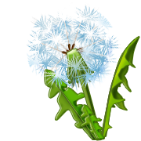 MC900391482[1] MC900365508[1] MC900331443[1]

Tomato Plant Dandelion Orange Tree Fir Tree Pine Tree

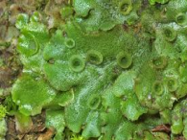 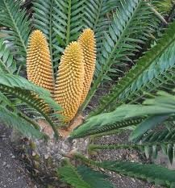 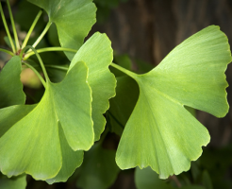 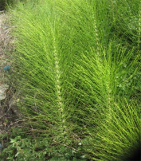 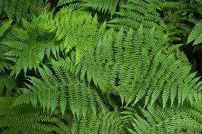

Liverworts Cycad Ginkgo Horsetails Ferns

MC900250842[1] MC900036433[1] 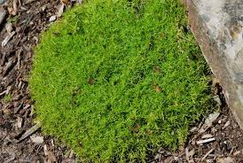 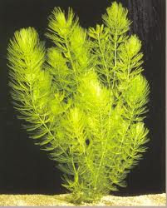

Green Beans Cedar Tree Moss Hornwort